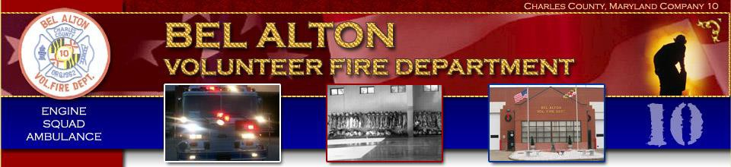
Pizza Hotline Fundraiser
Thursday, May 12, 2022; 4-7 pm
Sponsored by the BAVFD Auxiliary
9765 Bel Alton Newtown Rd, Bel Alton MD 20611
This Photo by Unknown Author is licensed under CC BY-NC
Coming Events  Pizza Hotline (Thursday, 4-7 pm)  June 16 October 20  July 21 November 17  August 18 December 15  Fried Chicken Dinner (Drive-Thru)  Friday, June 10, 5-7 pm | Limited Menu Items  Pizza (6 toppings to choose from)  Lasagna (Individual size)  Salad (Garden, Greek, Chicken Caesar)  Baked Goods Available – Please visit the Auxiliary bake table. Donations appreciated.

